NASTP Institute of Information Technology


Submitted To: Sir Hammad

Submitted By: Huzaifa Hassan

Rollno : S2025AI036

Semester: 4th Semester – Fall 2026

Subject: AI LAB

Objective
The objective of this laboratory session is to apply Object-Oriented Programming (OOP) paradigms in Python to structure modular systems and model basic AI agent architectures:
- Designing classes with initialized instance attributes (__init__) and bound instance methods.
- Differentiating between class-level attributes (shared state) and instance-level attributes (object-specific state).
- Implementing inheritance hierarchies using base and derived classes to model specialized AI agents (LearningAgent, DecisionAgent).
- Managing internal agent state transitions (e.g., resource consumption through energy degradation) triggered by functional actions.
2. Theory
2.1 Classes, Objects, and Instance State
A class defines a blueprint for creating objects. In Python, the constructor method __init__(self, ...) binds initial values to instance attributes via the explicit reference parameter self. Instance attributes are stored in each object's private namespace dictionary (__dict__), meaning mutations to one object's state do not affect other instances.
2.2 Class Attributes vs. Instance Attributes
- Instance Attributes: Bound to self. Each object maintains an isolated copy in memory.
- Class Attributes: Defined directly within the class body outside any method. They are shared across all instances of that class and reside in the class namespace. Updating a class variable via ClassName.variable_name += 1 inside __init__ enables global tracking of instantiation events without requiring external global counters.
2.3 Inheritance and Polymorphism in AI Agents
Inheritance allows a derived class (subclass) to acquire attributes and behaviors from an ancestor class (superclass):
- Base Class (Agent): Defines universal baseline agent state properties (such as name and energy) and shared lifecycle mechanics (such as energy depletion via act()).
- Derived Classes (LearningAgent, DecisionAgent): Extend the base class with specialized behaviors (learn() for knowledge acquisition, decide() for action selection) while inheriting baseline energy constraints and execution methods.
3. Tools / Software / Libraries
- Language: Python 3.x
- Development Environment: Visual Studio Code / Terminal
- Libraries: Standard Built-in Python Runtime (no third-party packages required)
4. Procedure / Methodology
- Simple Class and Object Instantiation (Task 1):
  - Defined class Car taking brand and speed as arguments in the constructor.
  - Implemented an instance method drive() displaying a formatted string indicating current operating speed.
  - Created two separate Car instances with distinct state values and invoked drive() on each.
- Class Attribute Tracking (Task 2):
  - Augmented Car with the class-level counter total_cars = 0.
  - Modified __init__ to increment Car.total_cars by 1 upon each instantiation.
  - Instantiated three discrete Car objects and displayed the resulting class attribute value.
- Hierarchical AI Agent System (Task 3):
  - Implemented base class Agent initialized with name and default energy = 100.
  - Defined method act() within Agent to decrement energy by 10 per execution cycle while preventing negative energy levels.
  - Created subclass LearningAgent(Agent) containing specialized method learn(topic) which invokes act() to reflect operational energy expenditure.
  - Created subclass DecisionAgent(Agent) containing specialized method decide(options) that evaluates options, prints the chosen strategy, and invokes act().
  - Instantiated one object of each agent subclass, executed their actions across multiple cycles, and inspected their terminal energy levels.
6. Observations
- Class attributes are accessed either via the class identifier (Car.total_cars) or through instances, but assigning through an instance (self.total_cars = ...) creates a shadowing instance attribute rather than updating the shared class state.
- Subclasses inheriting from Agent access base methods (act()) without code duplication, ensuring consistent state updates across different agent implementations.
- Encapsulating resource tracking inside methods prevents external functions from corrupting internal agent state variables directly.
7. Analysis / Discussion
- State Isolation: In Task 1 and Task 2, instance attributes stored unique data for each vehicle, while total_cars persisted across instances. Updating total_cars via Car.total_cars += 1 correctly modifies the single shared integer stored in the class namespace.
- Modular Architecture: In Task 3, separating general agent properties from specialized behaviors establishes an extensible pattern. If new agent behaviors are added (such as PlanningAgent or ReflexAgent), they can inherit from Agent without modifying existing agent implementations.
- Resource Degradation: Tying domain actions (learn(), decide()) to energy reduction models finite resource environments, an essential concept when designing utility-based and goal-directed agents in later labs.
8. Conclusion
The laboratory exercises demonstrated core Object-Oriented Programming principles in Python. Instantiation, method invocation, shared class state tracking, and class inheritance were implemented and verified. Structuring an agent hierarchy established an OOP pattern for building modular, state-driven AI systems.

Task 1
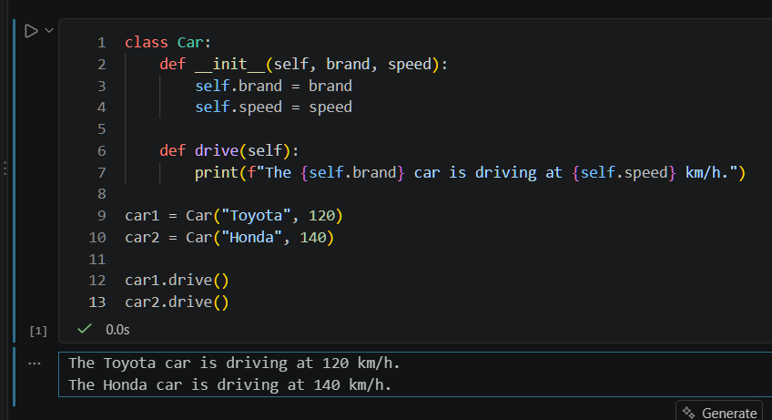
Task2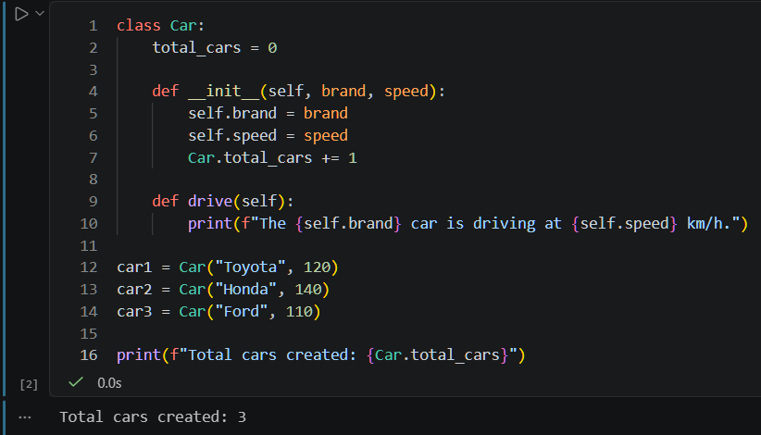

Task3